Please use this as the tiling texture (included):



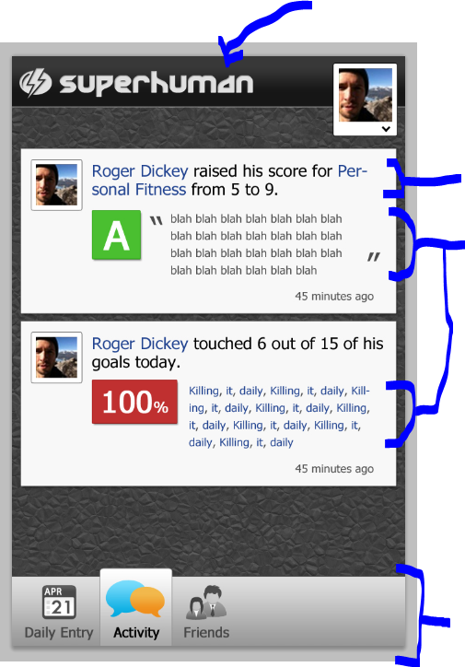

* The title should be a link, and should light up when tapped (this could happen either through the title color changing from light grey to white, or with some kind of outer glow)
* The profile picture in the upper right is tappable & will bring up a menu. More on that in a later screen.
* This view contains a series of “activity stories”. There could be many, so the area between the top & bottom bars should be scrollable with a scroll system similar to the iPhone’s native scroll. The top & bottom bars should remain fixed at all times.
* The title text of each activity story should be changeable, and should affect the position of other elements in the story. The body text of the activity story should also be changeable which should affect the height of the story.
* All text should be customizable unless otherwise specified

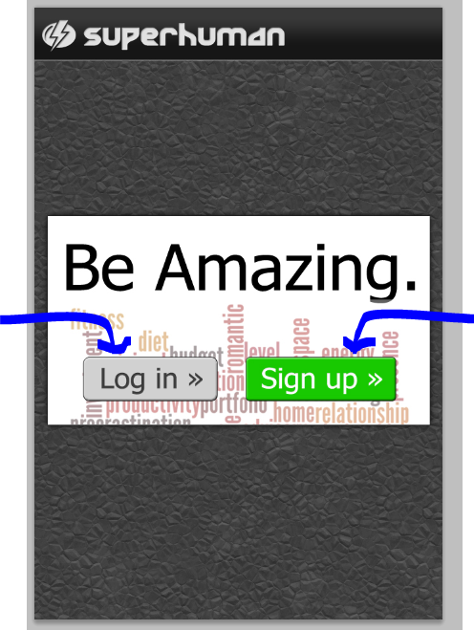

* The “log in” button is a link, should appear to press when tapped, ie bevel should flip
* “sign up” should behave the same as “log in” when tapped, but instead of being a link it should cause the “be amazing” box to animate & expand to the box shown in the next view below

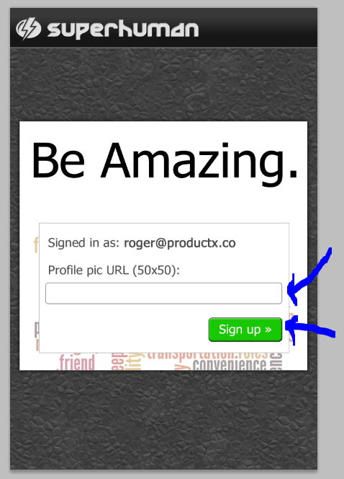

* The input box is a text entry
* All text should be customizable, as usual
* The “sign up” button should submit the form

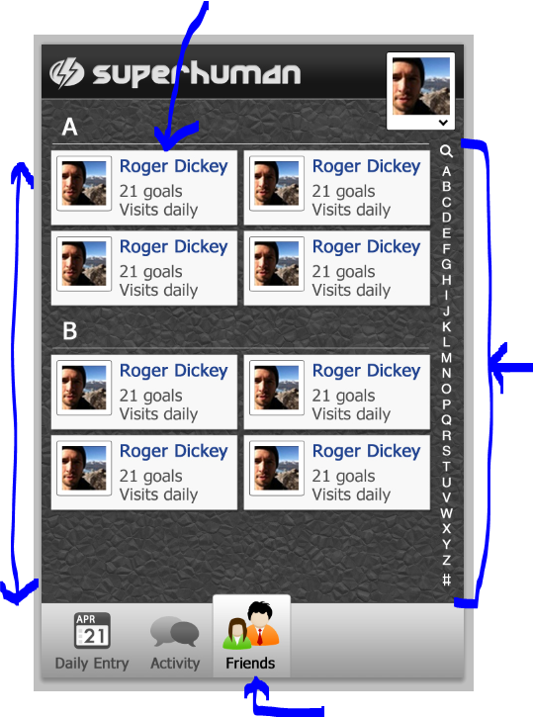

* This view displays a list of friends. There may be many friends, so the view should be scrollable as mentioned above (similar to the iPhone’s scroll system). Just sections A & B are shown here for simplicity.
* Clicking on one of the letters at right should move the scroll position to that letter
* All text should be changeable. Long names or user descriptions (“21 goals; visits daily”) should wordwrap & cause the user cards to grow in height.
* The icons on the bottom bar should highlight according to the currently active view. In this view the “friends” icon would be highlighted.

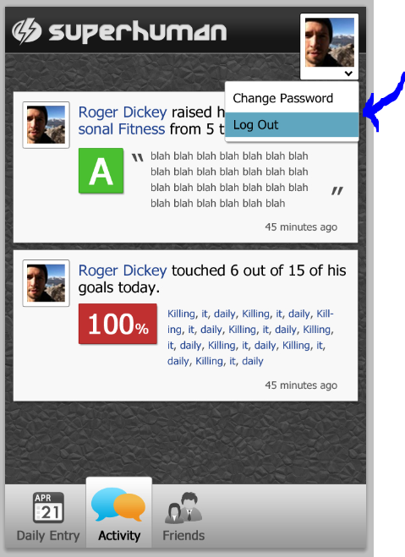

* If the user taps their profile picture, the settings menu should display. Tapping an item in the settings menu should cause its background to change color.
* All items in the settings menu are links

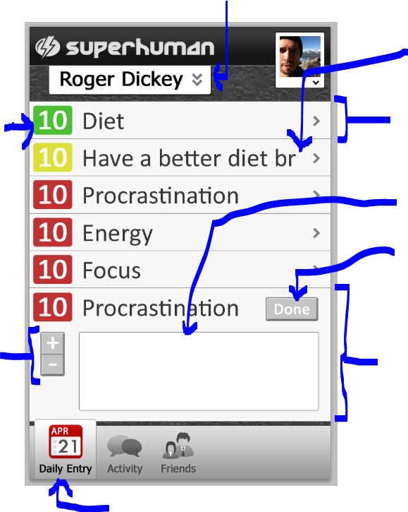

* This view shows a list of goals the user may have, such as improving their diet, having more energy & focus, procrastinating less, etc.
* Tapping the name “Roger Dickey” should cause all goals to expand, ie should have the same effect as tapping the name of every goal.
* Each goal has a number beside it. The color & number should be changeable. There are 3 colors: red, yellow, green.
* Goal names that are too long should be automatically cropped (if this is possible; see 2nd goal from the top as an example)
* Tapping the grey right arrow to the right of a goal should link to a different view.
* Tapping the name or number of a goal should cause it to expand. The last goal (the 2nd instance of “procrastination”) is an example of an expanded goal. This expanded goal is currently in mode B, showing the text input area & “done” button. The next slide will show mode A. Tapping “done” should submit the form & revert the expanded goal to mode A (ie it is still expanded, but is showing mode A’s content instead of mode B).
* The +/- buttons should be individually tappable. They should highlight somehow when tapped (all buttons should highlight when tapped).
* This is the daily entry page, so the daily entry icon in the bottom bar is shown as highlighted

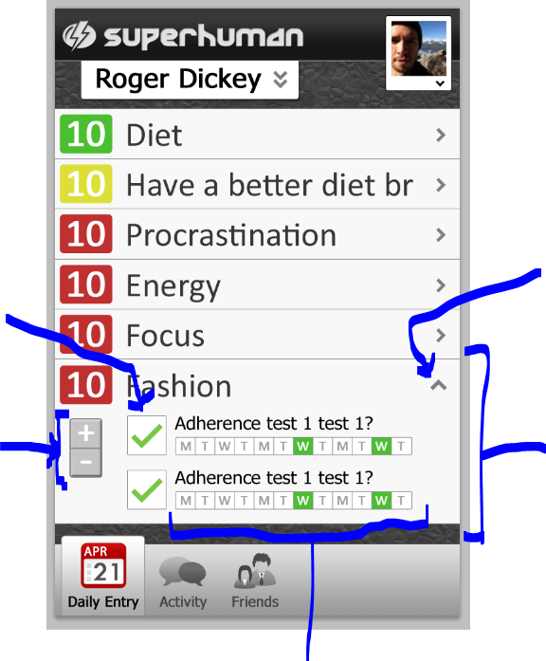

* This slide is identical to the previous, except that it shows an expanded goal in mode A, in this case the “fashion” goal.
* Tapping a goal should always expand it from a standard (short) goal row to the taller mode A, with animation. If the goal is partially off the bottom of the screen, the scroll position should adjust so the whole goal is shown.
* Tapping the up arrow in the upper right corner of an expanded goal should un-expand it back to a regular goal row.
* Tapping the +/- buttons should switch the expanded goal to mode B, expanding the goal row if necessary.
* The green checkboxes should toggle on & off when tapped.
* The row of small boxes (“M”, “T”, “W”, etc) should be dynamically colorable.

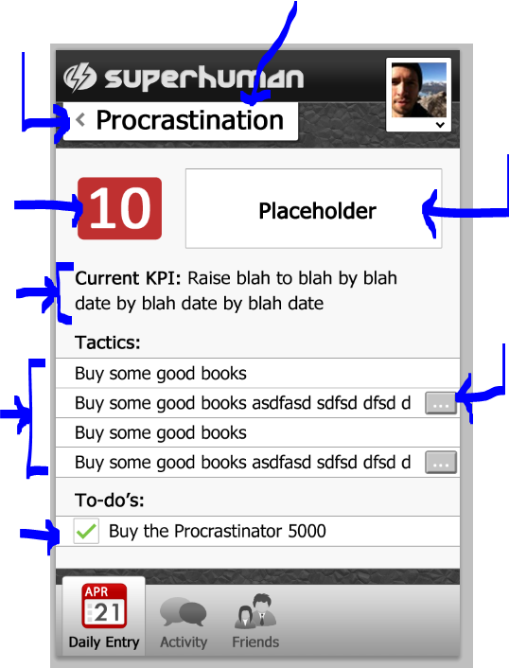

* The title “procrastination” should be changeable
* Tapping the title or the grey left arrow beside the title should link to another view
* The number “10” should be changeable & its background should be recolorable
* The box marked “placeholder” can just be an image.
* The text in the “current KPI” section should wordwrap & cause that section to have variable height
* The “tactics” section contains a set of rows. Some rows have a small amount of text, but some will have a large amount of text. The rows with a large amount should be able to have a “…” button beside them & the text should crop. Clicking the “…” button should expand the row (it doesn’t have to animate).
* The “to-do’s” section is the same as the “tactics” section, but items should have checkboxes next to them. Checkboxes should toggle on/off when tapped.
* This view could have a number of tactics & to-do’s, so it should be scrollable.